Monday

17.30 – 19.00 Tai Kwon Do
18.30 – 20.30 Motiv8 Youth Club
19.00 – 21.30 Healing Group

Tuesday

09.00 – 13.00 Advice Shop
10.00 – 11.30 “Knightsridge Angels” Coffee Morning
10.00 – 13.30 Cafe
11.30 – 12.30 Paracise
12.00 – 14.00 Food Outlet
15.30 – 18.00 Advice Shop (1st week of month)
16.00 – 18.00 Food Outlet
17.00 – 18.30 Community Meal
18.15 – 21.15 Little Stitch (3rd week of month)
19.00 – 21.00 Community Council (2nd week of month)
19.00 – 21.00 Management Committee (3rd week of month)

Wednesday

9.30 – 11.30 Mosswood Munchkins

9.30 – 11.30 Adult Learning

12.00 – 2.30 Community Inclusion

17.30 – 20.00 At the Root Arts
18.00 – 20.00 Having Your Say

Thursday

10.00 – 12.00 Community Inclusion
19.00 – 20.00 The Vennie

Friday

16:00 – 17:00 Line Dancing
18.00 – 19.00 The Vennie

Saturday

11.00 – 13.00 Tai Kwon Do

Sunday

9.30 – 13.00 Burnside Athletic AFC

Changing Rooms as Required

Hall available to hire for Functions/Birthday Parties
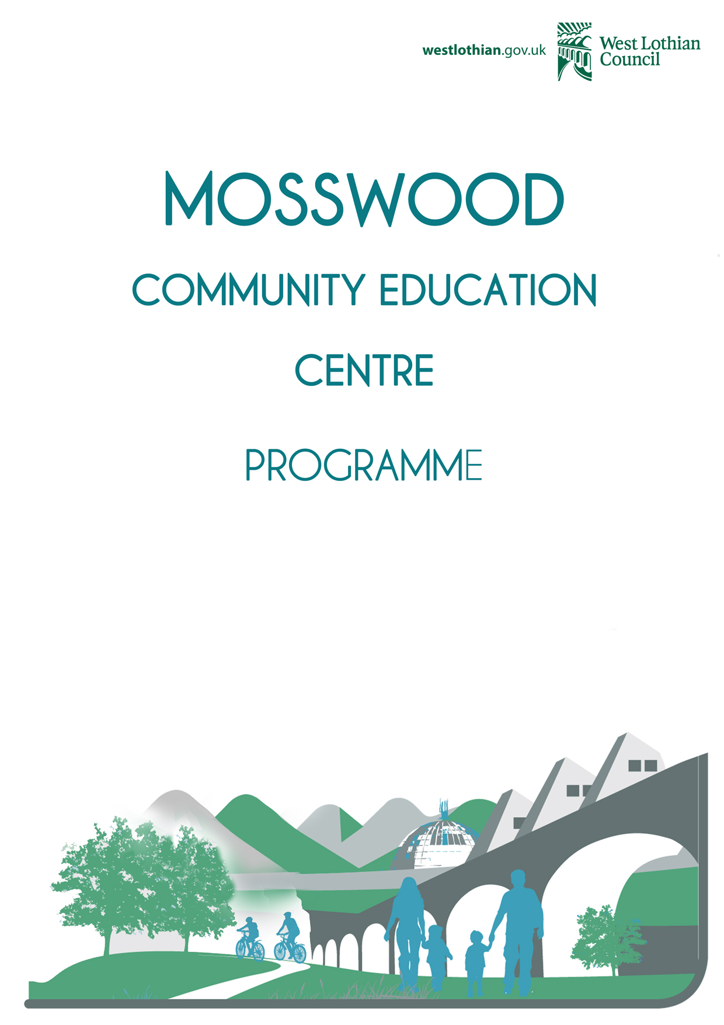
For further information please contact:
Sandra McLaughlin
Service Support Officer

Tel: 01506 437761
Mob: 07771 864 513
Email: sandra.mclaughlin@westlothian.gov.uk

Customer Facilities Assistants:
Festus Amadin
Craig Pennycook

2025
2023
Ben Slattery
James Welsh

Management Committee:
Chairperson
Laura Little

Vice Chairperson
Lorraine Girdwood

Secretary
Julie Henderson

Treasurer
Vic Kinghorn

